SUMMARY CHAPTER 10 CONTINUATION I
List Interface:
represents ordered collections
- Duplicates allowed, elements accessed by index values.
- Stores in ordered way.
Syntax:
List<Dataype> listname=new ArrayList<>();

ArrayList:
Dynamic array. Allows duplicates, maintain ordered values, access through index, slower when insertion or deletion performed in the middle.

Eg:
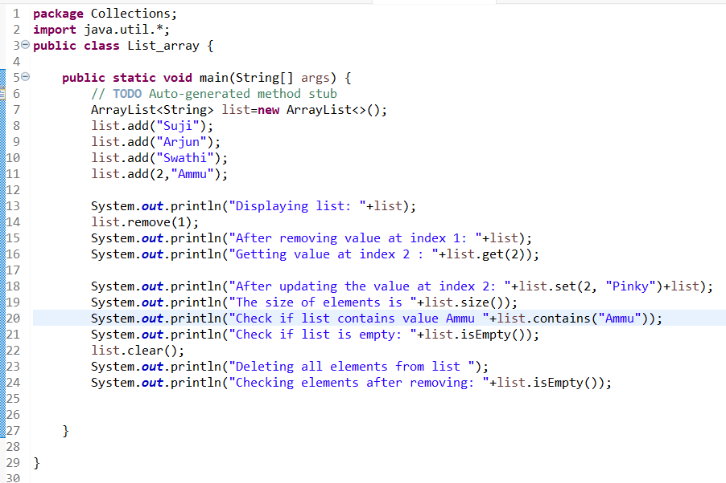

LinkedList:
- Involves doubly linked list.
- Used for insertion and deletion. Slower for random access.
- Doubly linked list: each node contains data and two pointers, one pointing to next node and another pointing towards the previous node.
Eg:
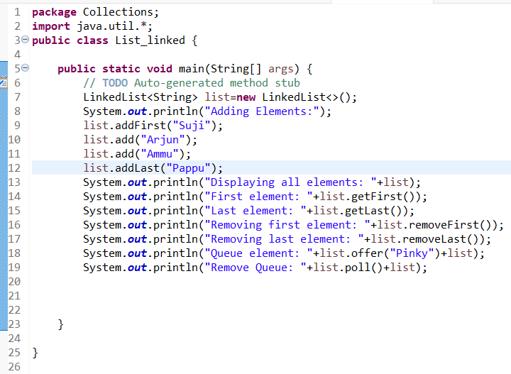

Vector:
dynamic array similar to arraylist but synchronized – thread safe.
- Slower than arraylist due to synchronization.
- Maintains insertion order, allow duplicates.

Eg:
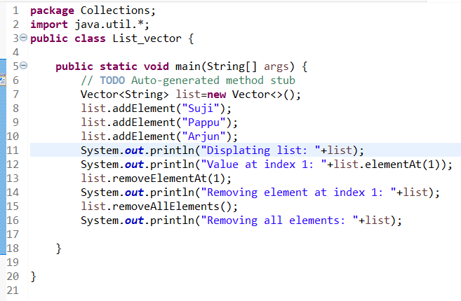

Stack:
- Subclass of vector have last in first out for storing and retrieving elements.
- Use push,pop,peek operations.
- Thread-safe.
- Slower due to synchronization.

Eg:
